National University of Computer and Emerging Sciences

Lab Manual
Computer Organization and Assembly Language


Lab 08

Instructor Wajahat Ali Khan
Class lab8 ,lab4
Semester Fall 2022

Fast School of Computing
FAST-NU, Lahore, Pakistan

Objectives
- String Processing
- STOS Example – Clearing the Screen
- LODS Example – String Printing
- SCAS Example – String Length
- MOVS Example – Screen Scrolling
Contents
Objectives 2
ACTIVITY 1: [20 Marks] 2
ACTIVITY 2: [20 Marks] 2
ACTIVITY 3: [40+20 Marks] 2
REFERENCES 3

Note for all questions: You can make as many memory variables, subroutines as you need. Must read all the manual before starting.

ACTIVITY 1: [20 Marks]
Write a subroutine which uses nested loops for creating a delay of around 3-5 secs.
Note: Do not use any special commands or interrupts for creating any delay.

ACTIVITY 2: [20 Marks]
Practice the following examples from Chapter 7 and display their outputs in report:
- STOS Example – Clearing the Screen
- LODS Example – String Printing
- SCAS Example – String Length
- MOVS Example – Screen Scrolling

ACTIVITY 3: [40+20 Marks]
- Use the subroutines developed in Activity 1 and Activity 2 to create an animation (of Start or End Screen) which shows the following information about you (every message with delay) as shown on the following figure and in the YouTube link [1]. (40 Marks)
Note: Do not pass string length parameter calculate string length automatically.
- Record a video of your animation through Mobile or any screen recorder and submit along with the report. (20 Marks)
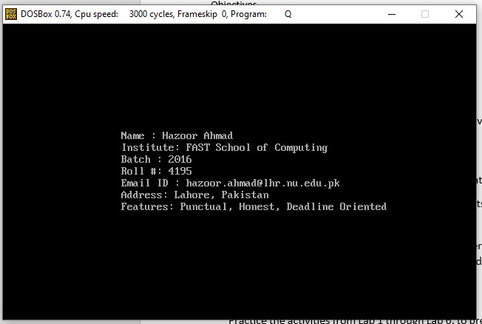

REFERENCES
- https://youtu.be/Anphs9zoP_c
- http://www.dosbox.com/download.php?main=1
- http://sourceforge.net/projects/nasm
- http://www.nasm.us/
- http://www.programmersheaven.com/download/21643/download.aspx (AFD)

